

Practices for Secure Software Report

Table of Contents
Document Revision History 3
Client 3
Instructions 3
Developer 4
1. Algorithm Cipher 4
2. Certificate Generation 4
3. Deploy Cipher 4
4. Secure Communications 4
5. Secondary Testing 4
6. Functional Testing 4
7. Summary 4
8. Industry Standard Best Practices 4

Document Revision History

Version | Date | Author | Comments
1.0 | 08/15/2026 | Cristian Alejandro | Project Two secure software report

Client



Instructions

Submit this completed practices for secure software report. Replace the bracketed text with the relevant information. You must document your process for writing secure communications and refactoring code that complies with software security testing protocols.

- Respond to the steps outlined below and include your findings.
- Respond using your own words. You may also choose to include images or supporting materials. If you include them, make certain to insert them in all the relevant locations in the document.
- Refer to the Project Two Guidelines and Rubric for more detailed instructions about each section of the template.

Developer
Cristian Alejandro
1. Algorithm Cipher
For Artemis Financial, I used SHA-256 (Secure Hash Algorithm 256-bit) to create the checksum used for data verification. SHA-256 is a cryptographic hash function that takes input data and produces a fixed 256-bit digest. Even a small change to the original data produces a different hash, which makes it useful for checking integrity.
SHA-256 is part of the SHA-2 family. A hash function does not encrypt data and does not use a key; it creates a one-way digest that can be compared to another digest to determine whether data changed. For confidential data encryption, a modern cipher such as AES is appropriate. AES is symmetric and supports 128-, 192-, and 256-bit keys. Symmetric encryption uses the same secret key for encryption and decryption, while asymmetric encryption uses a public/private key pair. Cryptographically secure random numbers are also important for generating keys and other security-sensitive values.
Older algorithms such as DES and weak hashes such as MD5 and SHA-1 are no longer appropriate for modern security because of known weaknesses and advances in computing. Modern applications should use current, well-supported algorithms with sufficient bit strength. SHA-256 is appropriate for this project because Artemis Financial requires a checksum that can verify the integrity of transferred data.
2. Certificate Generation
I generated a self-signed certificate with Java Keytool and exported the public certificate as a CER file. The project also contains the PKCS12 keystore used by the Spring Boot HTTPS configuration.
Screenshot of the CER file:
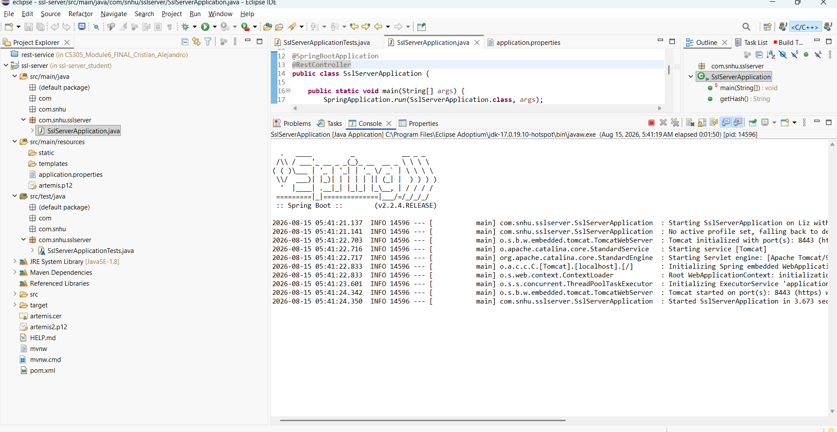
Figure 1. Eclipse project showing artemis.cer and the PKCS12 keystore.
3. Deploy Cipher
I refactored the application to use Java's SHA-256 MessageDigest implementation. The /hash endpoint uses a unique data string containing my name and Artemis Financial and displays the original data, algorithm, and generated checksum.
Screenshot of the checksum verification:
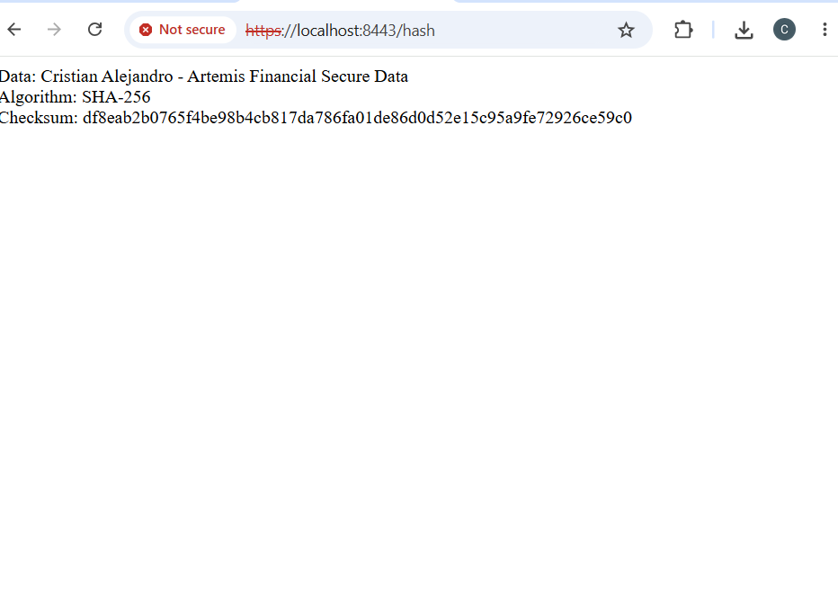
Figure 2. SHA-256 checksum verification for the unique Artemis Financial data string.
4. Secure Communications
I configured Spring Boot to use SSL/TLS on port 8443 and verified the /hash endpoint using HTTPS. The application successfully established an HTTPS connection and returned the SHA-256 checksum over the encrypted transport. Because this project uses a self-signed certificate created for local development, the browser displays a trust warning. This warning does not mean the application fell back to HTTP; the address uses https:// and the Spring Boot server is configured for SSL/TLS on port 8443. In a production environment, Artemis Financial would use a certificate issued by a trusted certificate authority so browsers could validate the certificate chain without a warning.
Screenshot of the HTTPS webpage:

Figure 3. HTTPS endpoint at localhost:8443/hash using the self-signed development certificate.
5. Secondary Testing
After refactoring the application, I ran the OWASP Dependency-Check Maven plug-in. The Maven build completed successfully and generated a dependency-check report. The report identifies known vulnerabilities in older dependencies included with the supplied project. I reviewed the secondary scan after the security changes to check that the refactoring did not require additional vulnerable third-party libraries.
Screenshots of the successful execution and dependency-check report:
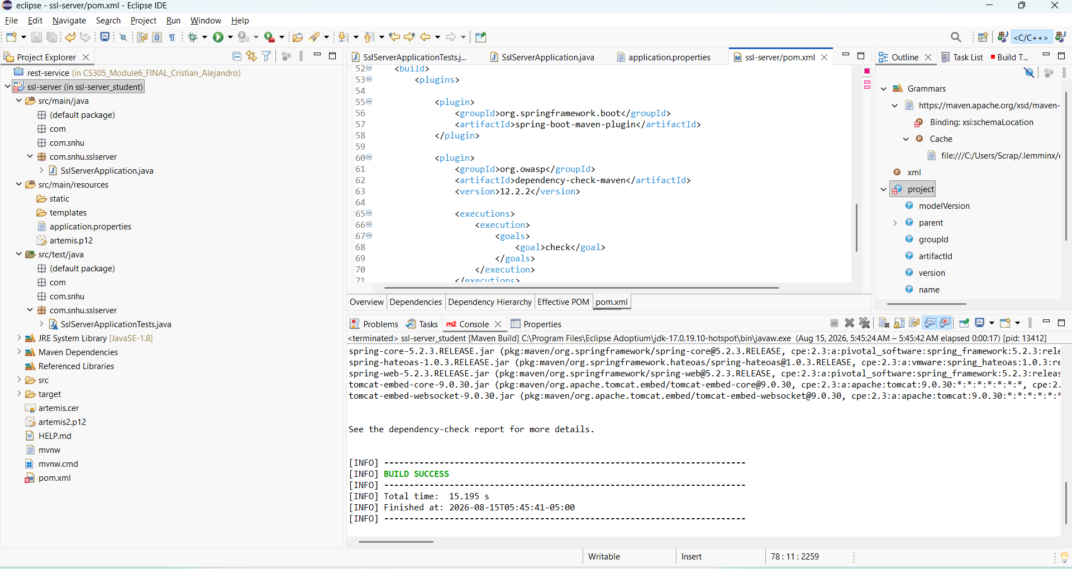
Figure 4. OWASP Dependency-Check execution completed with BUILD SUCCESS.
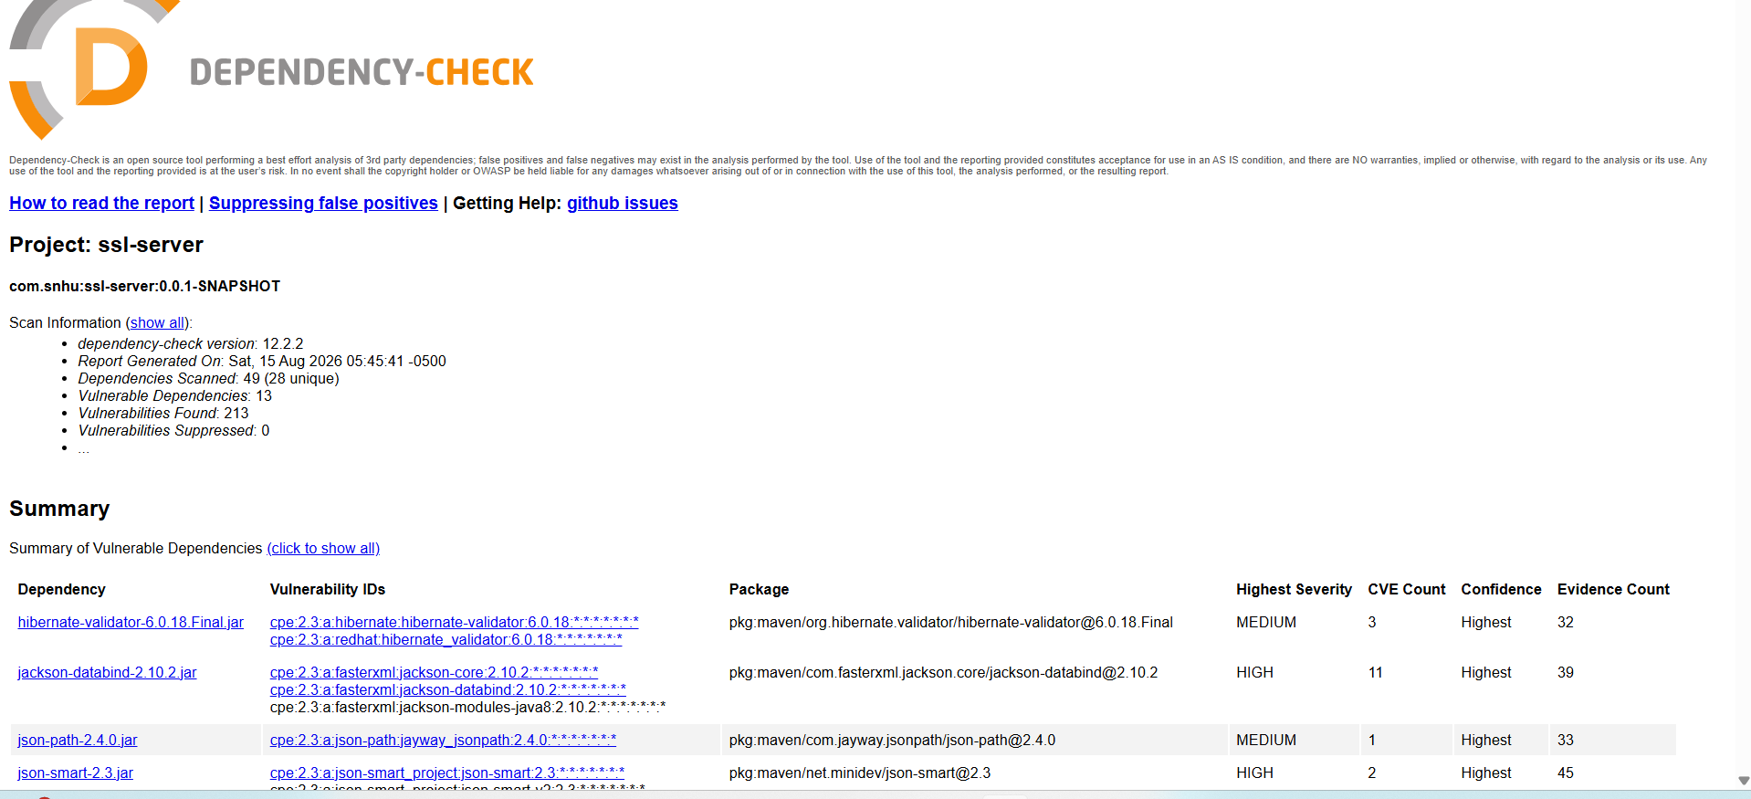
Figure 5. Secondary OWASP Dependency-Check report for the ssl-server project.
6. Functional Testing
I manually reviewed and executed the refactored application for syntactical, logical, and security problems. For syntactical testing, I compiled and ran the application and confirmed that the Spring Boot server started without Java compilation or startup errors. For logical testing, I verified that the /hash route accepted the intended data string and consistently returned a SHA-256 checksum in the expected hexadecimal format. For security testing, I reviewed the code to confirm that SHA-256 was provided by Java's standard MessageDigest implementation, HTTPS was enabled through Spring Boot SSL/TLS settings, and the application did not require a new third-party cryptography library for the checksum. I also confirmed that the PKCS12 keystore was used by the HTTPS configuration. The successful execution on port 8443 and the expected /hash response showed that the security changes preserved the application's functionality.
Screenshot of the refactored code executed without startup errors:

Figure 6. Refactored Spring Boot application running successfully on port 8443.
7. Summary
I refactored the Artemis Financial application to add multiple layers of security. I added a SHA-256 checksum endpoint so data can be verified for integrity. I generated a self-signed certificate and configured the application to use SSL/TLS on port 8443 so communication occurs through HTTPS instead of HTTP. I also integrated OWASP Dependency-Check and ran secondary static testing after the changes.
The refactoring addressed secure communications, cryptography, dependency analysis, and code quality. I used a layered approach rather than relying on a single control. HTTPS protects information in transit, the certificate supports encrypted communication, SHA-256 provides integrity verification, and dependency checking identifies known risks in third-party components.
The application executed successfully after the changes. The dependency-check report still lists vulnerabilities associated with older dependencies in the supplied code base. The SHA-256 functionality itself uses Java's standard MessageDigest implementation, so I did not need to add a new third-party cryptography dependency for the checksum.
8. Industry Standard Best Practices
I applied industry standard practices by using established Java and Spring Boot security features instead of creating a custom cryptographic algorithm. The checksum uses Java's standard SHA-256 MessageDigest implementation, and secure transport is configured through Spring Boot SSL/TLS settings. I generated and exported a certificate and used HTTPS to protect application traffic in transit.
I maintained the application's existing functionality while adding focused security controls. After refactoring, I tested the application, verified the checksum output, confirmed successful server startup, and ran OWASP Dependency-Check as a secondary static test. This supports an iterative process of reviewing, testing, and correcting security issues.
Following secure coding best practices is valuable to Artemis Financial because the company handles sensitive client and financial information. Secure development reduces the risk of data tampering, unauthorized disclosure, and avoidable vulnerabilities. It also improves maintainability by using recognized standards, repeatable testing, and supported security technologies.

